INDUSTRIAL TRAINING REPORT

On

WEATHER DASHBOARD
Submitted in Partial Fulfillment for the Award of
BACHELOR OF TECHNOLOGY

In
Information Technology

(BATCH: 2026)

By

[NEHA KUMARI (22001304037)]


FACULTY OF ENGINEERING AND TECHNOLOGY
(Uma Nath Singh Institute of Engineering and Technology)

VEER BAHADUR SINGH PURVANCHAL UNIVERSITY, JAUNPUR (U.P.)

Industrial Training Certificate

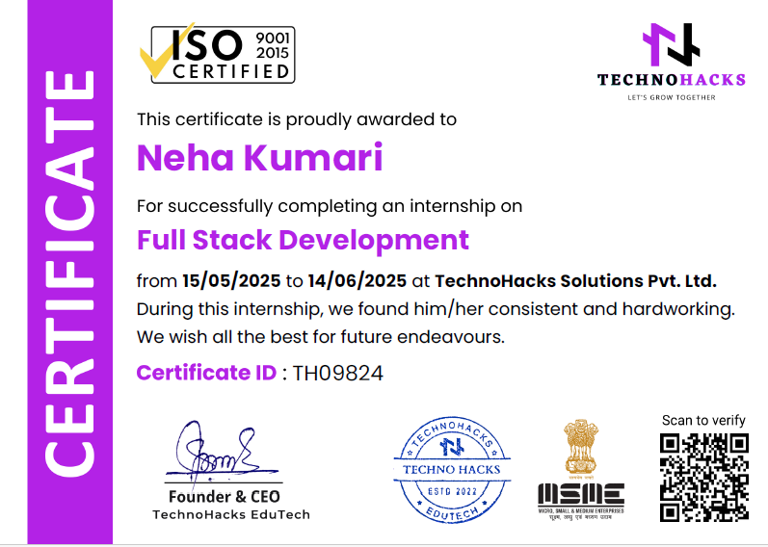

DEPARTMENT OF COMPUTER SCIENCE & ENGINEERING
FACULTY OF ENGINEERING AND TECHNOLOGY
(Uma Nath Singh Institute of Engineering and Technology)
VEER BAHADUR SINGH PURVANCHAL UNIVERSITY, JAUNPUR (U.P.)

----------------------------------------------
CO-ORDINATOR CERTIFICATE
----------------------------------------------

It is certified that, this industrial training report entitled “Weather Dashboard” submitted by Neha kumari [22001304037] in the partial fulfillment of the requirements for the award of the degree of Bachelor of Technology in Information Technology & Engineering of Veer Bahadur Singh Purvanchal University, Jaunpur (U.P.) is a record of student own study carried out during summer training/Internship.

Dr. Vikrant Bhateja
Mr. Purnendra Kumar
(Assistant Professor, IT) (Head of Department)

(Co-ordinator)

ACKNOWLEDGEMENT

I would like to express my sincere gratitude to TechnoHacks Solutions Pvt. Ltd. for providing me with the opportunity to undertake this industrial training and work on the project titled " Weather Dashboard Application". This internship has been a great learning experience that has enhanced my technical skills and practical knowledge.
I extend my heartfelt thanks to my mentor, Mr. Sandip Gavit, for his continuous guidance, valuable feedback, and encouragement throughout the training period. His expertise and support played a crucial role in the successful completion of this project.
I am also thankful to the Department of Information Technology, Uma Nath Singh Institute of Engineering and Technology, Veer Bahadur Singh Purvanchal University, Jaunpur (U.P.), for their academic support and for facilitating this training.

Date……………. Student’s Name
Place: UNSIET, Jaunpur Neha Kumari [22001304037]

TABLE OF CONTENTS
Industrial Training Certificate ii

Co-Ordinator Certificate iii

Acknowledgement iv

Table of Contents v-vi

- INTRODUCTION 1-3
  - Background of the Organization 1
  - Overview of the Internship 1
  - Purpose and Area of Focus 1
  - Need for the Project 2
  - Goals and Objectives 2

- OBJECTIVE OF INDUSTRIAL TRAINING 4-5
  - Gain Practical Experience 4
  - Enhance Professional and Soft Skills 4
  - Prepare for Future Employment 5
- INTRODUCTION ABOUT INDUSTRY 6-7
  - About the Company 6
  - Relevance to My Field of Study 7

- PROPOSED DESIGN METHODOLOGY 8-10
4.1 Solution Approach 8
4.2 Block Diagram 9
4.2.1 User Interface Module 9
4.2.2 Backend (Node.js) Module 10
4.2.3 Weather API Module 10
4.3 Module Description with Flowcharts 11-12

Appendix “A”

List of Figures vii

References & Bibliography viii

1.INTRODUCTION
1.1 Background of the Organization
The internship was completed at TechnoHacks Solutions Pvt. Ltd., a growing technology company focused on providing practical training, project-based learning, and technical solutions across various domains. The organization offers services in web development, app development, data science, AI/ML, and cybersecurity, while also running structured internship programs to help students gain real-world skills.
As part of their Internship Program 2025, TechnoHacks provided a platform where interns could work on live projects, explore trending technologies, and build strong foundations for their professional careers.
1.2 Overview of the Internship
During the internship, I worked on a project titled “Weather Dashboard”, which involved building a web application that allows users to search for real-time weather information by entering a city name or using their current location. The aim was to gain practical experience in web development by applying core concepts of front-end design and integrating a backend API call to fetch data from the OpenWeatherMap API. This also helped in understanding the process of connecting user interfaces with live external data sources.
This hands-on project helped in improving my coding skills, problem-solving abilities, and understanding of API integration and user experience design in web applications.
1.3 Purpose and Area of Focus
The purpose of this internship was to gain hands-on experience in full-stack web development by working on a real-world Weather Dashboard project. The focus was on building the frontend (using HTML, CSS, JavaScript) and the backend (using Node.js) to securely fetch and process weather data from the OpenWeatherMap API.
Key areas included designing a responsive and user-friendly interface, creating RESTful API endpoints in Node.js to handle weather data requests, managing data flow between the client and server, and ensuring secure API key handling. The project also involved improving skills in debugging, testing, and optimizing performance for better user experience. Additionally, the internship helped in enhancing soft skills such as communication, problem-solving, and time management through guided mentorship.
1.4 Need for the Project
With the increasing reliance on real-time information, access to accurate and up-to-date weather data has become essential for daily planning, travel, agriculture, outdoor activities, and safety precautions. However, many existing weather platforms are complex, cluttered, or require multiple steps to access relevant details. This project addresses the need for a simple, user-friendly Weather Dashboard that allows users to quickly retrieve weather information by city name or location. By integrating a Node.js backend to securely fetch and process data from the OpenWeatherMap API, the solution ensures both ease of use and secure API key management, making it practical for everyday users and scalable for future enhancements.
1.5 Goals and Objectives
The primary goals of the project were:
- To design and develop a clean, responsive, and user-friendly weather dashboard interface.
- To implement search functionality for retrieving weather information by city name or current location.
- To understand how data flows between the frontend interface and the Node.js backend.
- To integrate the OpenWeatherMap API for fetching and processing real-time weather data securely.
- To apply classroom knowledge of web development in a real-world project environment.
- To build a solid foundation for developing more advanced, data-driven web applications.
- To gain confidence in using web technologies like HTML, CSS, JavaScript, and Node.js.

2.OBJECTIVE OF INDUSTRIAL TRAINING
2.1 Gain Practical Experience
The primary aim of industrial training is to provide students with real-world exposure to how actual companies and industries operate. It allows them to apply the theoretical knowledge learned in classrooms to real tasks and challenges. Students get hands-on experience with industry-relevant tools, technologies, and workflows, which helps them understand how their academic learning translates into practical job roles.
By working on live or simulated projects, students learn how to follow structured development processes, handle technical issues, and meet deadlines. They get to observe professional environments, workflows, and the roles of team members, which adds depth to their understanding of how real systems function.
This practical experience also helps in developing confidence, encourages independent learning, and allows students to learn from mistakes in a guided environment. It becomes the foundation for building strong problem-solving and decision-making abilities.
2.2 Enhance Professional and Soft Skills
Industrial training not only focuses on technical knowledge but also plays a vital role in developing professional behavior and essential soft skills. Students learn how to work effectively in teams, communicate ideas clearly, and present their thoughts confidently. These interpersonal skills are crucial for workplace success, regardless of the technical field.
Interns are exposed to real-time collaboration with team members, supervisors, and sometimes clients, helping them understand how to handle feedback, participate in discussions, and resolve conflicts professionally. Regular meetings and task planning improve their communication, leadership, and organizational skills.
Additionally, time-bound tasks and project responsibilities teach the importance of time management, adaptability, and accountability. Interns learn how to prioritize work, meet deadlines, and stay focused under pressure—skills that are essential in any job role.
By the end of the training, students become more confident, responsible, and prepared to work efficiently in a team-based, goal-oriented environment.
2.3 Prepare for Future Employment
Industrial training helps students become job-ready by introducing them to the actual expectations of the industry. They gain insights into industry standards, work culture, client interaction, and professional behavior. It also helps them discover their strengths, interests, and potential career paths, which is valuable for making informed career decisions.
Interns learn to follow structured workflows, use modern tools and platforms, and understand how tasks are assigned and monitored in a real job environment. Exposure to such practices makes them more confident and capable of working in dynamic and competitive workplaces.
They also learn the importance of professional ethics, time discipline, and how to present themselves during interviews and workplace interactions. By the end of the training, students are better prepared to handle technical interviews, adapt to job roles, and transition smoothly into the professional world with a stronger resume and real project experience.

3.INTRODUCTION ABOUT INDUSTRY
3.1 About the Company
TechnoHacks Solutions Pvt. Ltd. is a technology-driven private limited company based in Nashik , Maharashtra, India, focused on delivering high-quality software solutions and training services and Digital Marketing Agency. The company is widely recognized for its project-based internship programs, which are designed to give students hands-on experience in real-world projects.
TechnoHacks specializes in various domains such as:
- Full Stack Web Development
- Mobile App Development
- Data Science and Machine Learning
- Cybersecurity and Ethical Hacking
- Python, Java, and Cloud Computing
One of the key strengths of TechnoHacks is its flexible training model, offering internships in both online and offline modes. This blended approach allows students to choose a format that suits their availability and learning preferences. Through online platforms, students can access mentorship, resources, project guidance, and submit their work from anywhere. For those who prefer a more traditional setup, offline sessions provide direct interaction and personalized support.
This hybrid model ensures broader accessibility while maintaining the quality and effectiveness of learning. The company also focuses on developing industry-ready skills by combining technical training with soft skill development, regular reviews, and structured feedback.
3.2 Relevance to My Field of Study
As a student of Computer Science and Information Technology Engineering, this internship aligned closely with my academic background. It allowed me to gain hands-on experience in real-time software projects, particularly in the area of full stack development.
I worked on technologies such as HTML, CSS, JavaScript, and also gained exposure to backend logic, database integration, and RESTful API development. This enabled me to understand how the frontend and backend communicate in a complete web application. I also explored the software development lifecycle (SDLC), including version control using Git, testing, and deployment processes.
The internship helped me improve my technical abilities, enhanced my understanding of how actual IT companies function, and taught me essential professional skills like communication, time management, teamwork, and project planning.
Additionally, I learned how to follow coding standards, participate in virtual team collaborations, and work under deadlines, simulating a real workplace environment. I received constructive feedback from mentors, which further refined my coding and problem-solving skills.
This experience significantly contributed to bridging the gap between theoretical learning and practical implementation, helping me build confidence and prepare for future career opportunities in the tech industry

4. PROPOSED DESIGN METHODOLOGY
4.1 Solution Approach
The proposed solution for the industrial training project is to design and develop a Weather Dashboard web application with a Node.js backend and a responsive, interactive frontend.
1. Backend (Node.js + Express)
- Acts as a secure middleware to hide the OpenWeatherMap API key.
- Handles HTTP requests from the frontend, fetches real-time weather data from the OpenWeatherMap API, and sends processed data back in JSON format.
- Improves security by preventing direct exposure of the API key to the client.
- Ensures better performance by reducing direct API calls from the browser.
2. Frontend (HTML, CSS, JavaScript)
- Provides a clean, responsive user interface for seamless user experience.
- Allows users to search weather by city name or use their current location with Geolocation API.
- Displays weather details dynamically, including:
  - Temperature
  - Weather condition (e.g., Clouds, Rain, Clear Sky)
  - Humidity
  - Wind speed
  - Custom weather advice in English and Hindi based on conditions
- Includes functional buttons for Search, Use My Location, Clear, and Restart.
3. Key Features
- Real-time weather updates.
- Dual-language advice (English + Hindi).
- Responsive design for desktop and mobile devices.
- Clear and Restart functions for a fresh search experience.
4.Benefits of the Approach
- Security: API key hidden via backend.
- Performance: Optimized data fetching.
- User-friendliness: Minimal steps for weather info retrieval.
- Maintainability: Modular code for easy updates.
4.2 Block Diagram
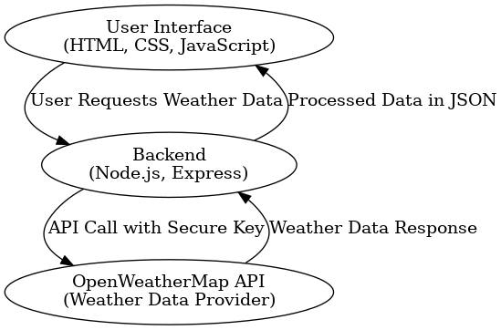
Fig No. 4.2 Block Diagram Weather Dashboard
4.2.1 User Interface Module:-
- Provides search bar for city input and buttons for location-based search.
- Displays weather details (temperature, humidity, description, icon).
- Handles user interactions and sends requests to the backend.
4.2.2 Backend (Node.js) Module:-
- Receives requests from the frontend.
- Calls the OpenWeatherMap API securely using the stored API key.
- Processes and formats the received weather data.
- Sends the processed data back to the frontend in JSON format.
4.2.3 Weather API Module:-
- External data provider (OpenWeatherMap).
- Supplies real-time weather details based on city name or coordinates.

4.3 Module Description with Flowcharts
Module 1: User Interface
- Input: City name or geolocation coordinates.
- Output: API request sent to backend.
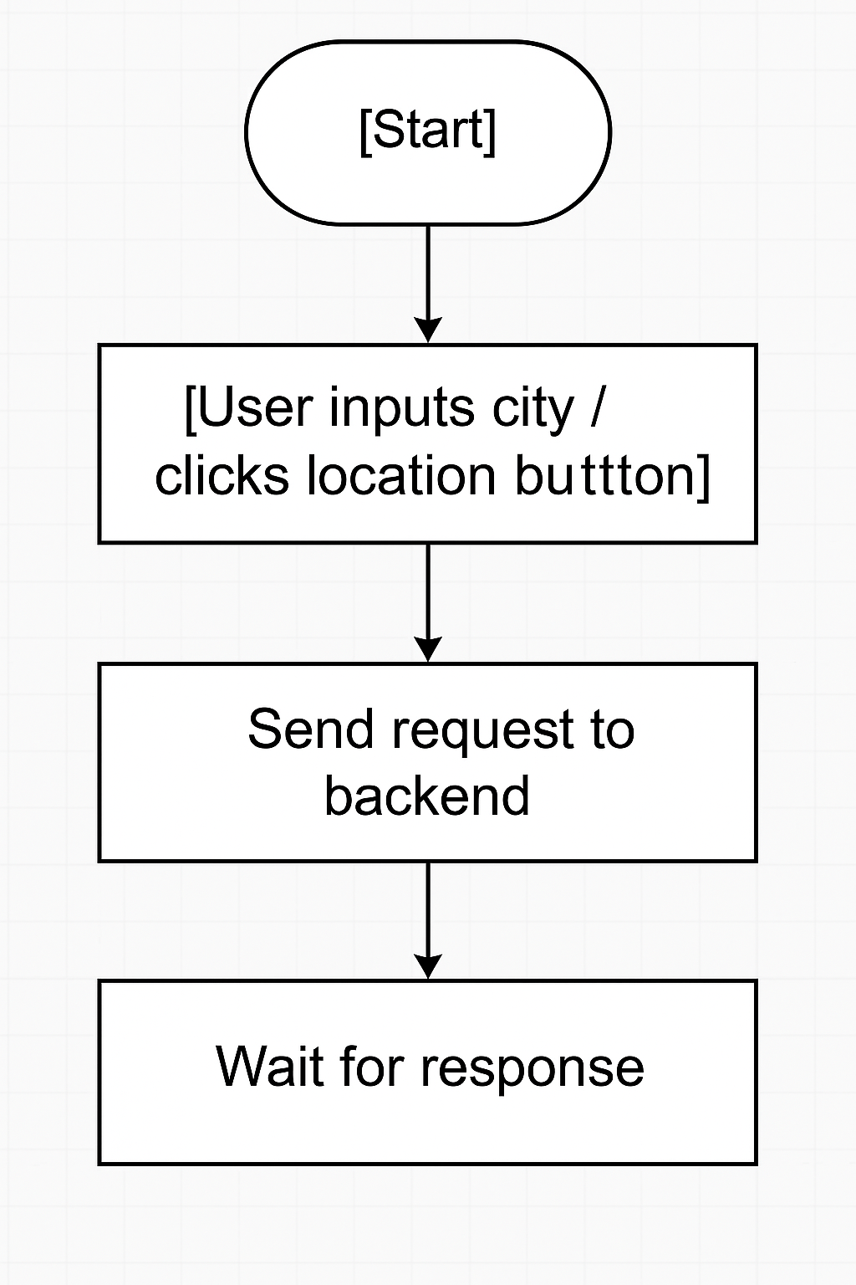
Fig No. 4.3.1 Flowchart of User Interface
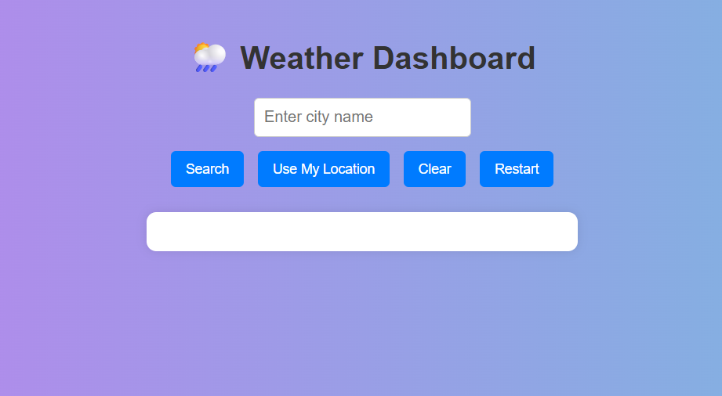
Fig No. 4.3.2 User Interface

Module 2: Backend Processing
- Input: City name or coordinates from frontend.
- Process:
- Validate input.
- Call OpenWeatherMap API using Node.js .
- Format data (temperature in °C, weather description, etc.).

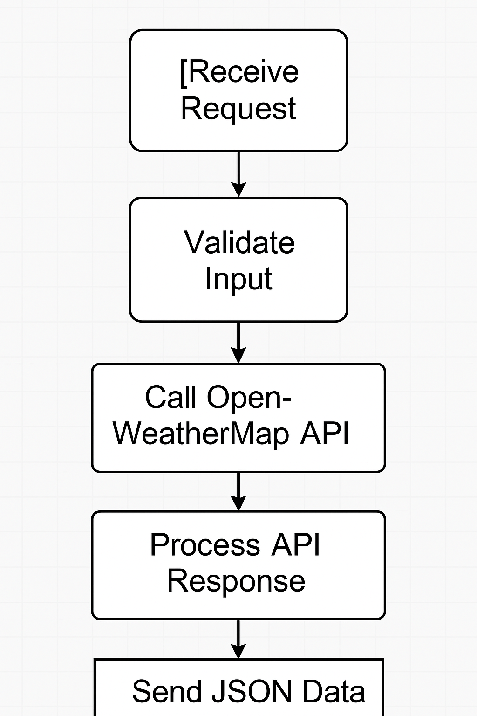
Fig No. 4.3.3 Flowchart of Backend Processing
Module 3: Display Module
- Input: Weather data from backend in JSON format.
- Process: Update DOM elements with weather details.
- Output: Weather dashboard with updated details.
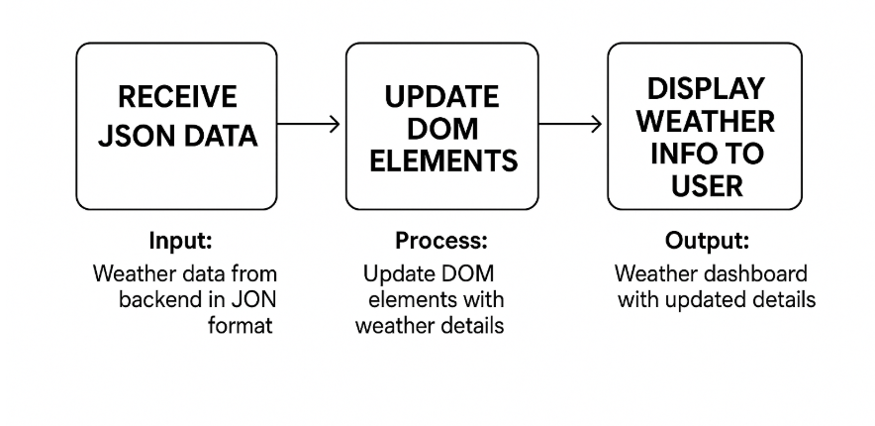
Fig No. 4.3.4 Flowchart of Display Module
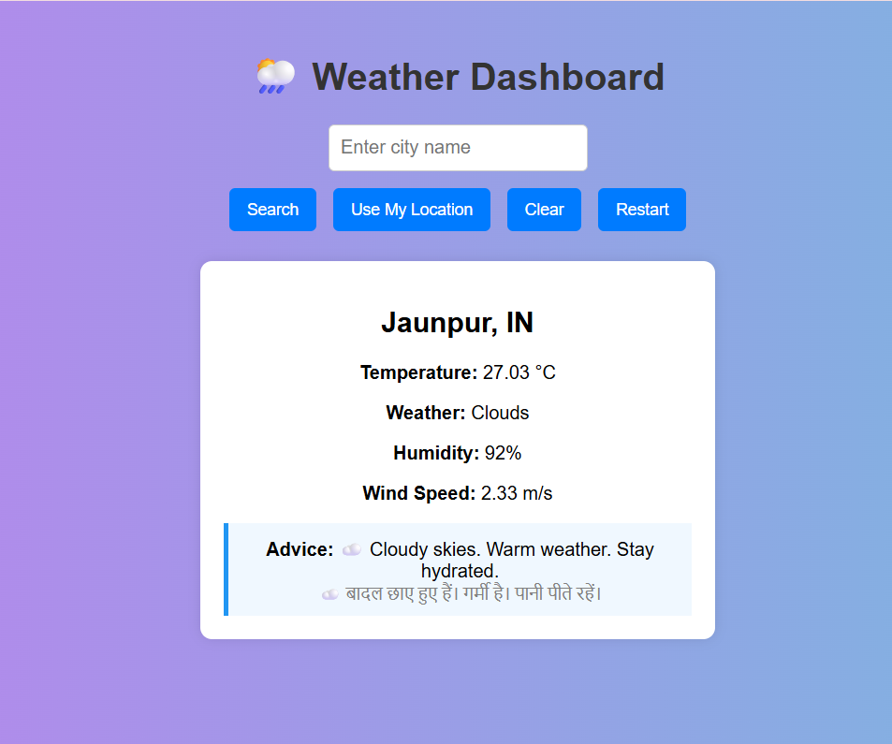
Fig No. 4.3.5 Display Weather Information.

APPENDIX “A”

List of Figures

Fig No. Figure Name Page No.

Fig No. 4.2 Block Diagram Weather Dashboard 9
Fig No.4.3.1 Flowchart of User Interface 10
Fig No. 4.3.2 User Interface 11
Fig No. 4.3.3 Flowchart of Backend Processing 11
Fig No. 4.3.4 Flowchart of Display Module 12
Fig No. 4.3.5 Display Weather Information. 12

References & Bibliography
- OpenWeatherMap. Current Weather Data API. Available at: https://openweathermap.org/api
- MDN Web Docs. JavaScript Documentation. Available at: https://developer.mozilla.org/en-US/docs/Web/JavaScript
- W3Schools. HTML, CSS, and JavaScript Tutorials. Available at: https://www.w3schools.com/
- Node.js Official Documentation. Node.js v20.x API Reference. Available at: https://nodejs.org/en/docs/
- Express.js Documentation. Web Application Framework. Available at: https://expressjs.com/
- Bootstrap. Frontend Framework Documentation. Available at: https://getbootstrap.com/docs/
- Visual Studio Code. Official Documentation. Available at: https://code.visualstudio.com/docs
- FreeCodeCamp. How to Build a Weather App with JavaScript. Available at: https://www.freecodecamp.org/
- GeeksforGeeks. Node.js and Express Tutorials. Available at: https://www.geeksforgeeks.org/

